Final Project I AESM3030
A single-phase 1D hydrogen
storage reservoir simmulation
Authors:
- Keith Polak (___)
- Nanda Afif (6424732)

Datum: April 2026
MSc. Earth, Climate, and Technology

Final Project I AESM3030
A single-phase 1D hydrogen storage reservoir simmulation

Content
1 Abstract 5
2 Formulations and Method 6
2.1 Mathematical Formulations, Discretization, and Simulation Approach 6
2.2 Boundary and Initial Conditions 7
3 Results 8
3.1 Simulation and Evaluation of Spatiotemporal Evolution of Pressure Distribution 8
3.2 Mass Velocity Field (ρU) Simulation and Evaluation 9
3.3 Simulation of Cummulative Hydrigen Gas Production 10
3.4 Grid Sensitivity Analysis 10
4 Discussion 12

Abstract
This study presents a 1D simulation of hydrogen flow in porous media using basic principles such as mass conservation, Darcy’s law, and the ideal gas equation. The model is solved using the finite volume method with an implicit time scheme. A production well is included using the Peaceman approach with a constant bottom-hole pressure. The results show how pressure changes over time as the reservoir is depleted. A clear pressure drop forms around the well and expands outward, while the boundaries remain unaffected due to no-flow conditions. The flow direction is always toward the well, as shown by the mass velocity (ρU), with the highest values near the well and decreasing over time as pressure declines. The cumulative production increases quickly at early time and then slows down. At the end of the simulation, about 10.45 kg of hydrogen is produced, which is equivalent to 104.5 m³ at standard conditions. A grid sensitivity analysis shows that results are stable for moderate grid sizes (nx = 10 and 100). However, using a very fine grid (nx = 1000) gives unrealistic results due to limitations in the Peaceman well model when the grid size becomes too small compared to the well radius. Overall, this study shows the importance of choosing an appropriate grid size to obtain reliable simulation results.

Formulations and Method

Mathematical Formulations, Discretization, and Simulation Approach
The governing equation for single-phase compressible hydrogen flow in 1D porous media is derived from mass conservation, Darcy's law, and ideal gas equation of state:
$$ϕc_{g}\frac{∂p}{∂t}=\frac{k}{μ}\frac{∂^{2}p}{∂x^{2}}+\frac{q}{ρ}$$
where gas compressibility $c_{g}=\frac{1}{p}$ (ideal gas) and density $ρ\left(p\right)=ρ_{0}\frac{p}{p_{0}}$.

For discretization of that formula, the finite volume method is utilized, with central difference scheme for spatial discretization and fully implicit time-stepping (backward euler), as a formulation below:
$$Θ_{i}\left(p_{i}^{n+1}-p_{i}^{n}\right)=F_{i-1/2}^{n+1}-F_{i+1/2}^{n+1}+Q_{i}^{n+1}$$
where $Θ_{i}=\frac{V_{i}ϕ}{Δt}$ is accumulation coefficient, $F_{i+1/2}=Tρ_{i+1/2}^{upwind}\left(p_{i+1}-p_{i}\right)$ is mass flux with upwind density weighting, $T=\frac{kA}{μΔx}$is transmissibility, and $Q_{i}$ = well term.
For well model, the production well is located at cell $i_{w}=n_{x}/2=50$ (domain center at $x=50$ m). It is modeled using the Peaceman well index:
$$Q_{w}=Γ_{w}\left(p_{i_{w}}^{n+1} − p_{bhp}\right)$$
where $Q_{w}$ = well production rate [m³/s at reservoir conditions], $p_{i_{w}}^{n+1}$ = grid block pressure at well location [Pa], and $p_{bhp}$ = prescribed bottom-hole pressure constraint [Pa] (given as 20 bar = $2.0×{10}^{6}$ Pa). Meanwhile, the the productivity index (based on Peaceman, 1983) is defined as:
$Γ_{w}=\frac{2πkh}{μ\left[\ln\left(\frac{r_{0}}{r_{w}}\right)+S\right]}$ , $r_{0}=0.208Δx$
where $k$ is the permeability of the reservoir (given as 1 Darcy, equivalent to $9.87×{10}^{-13}$m²), $h$ is the perforation thickness representing the vertical extent of the well completion (equal to $Δz$ in this 1D formulation), and $μ$ is the dynamic viscosity of hydrogen (H₂), approximately $8.9×{10}^{-6}$Pa·s under reservoir conditions. The wellblock radius $r_{0}$ is computed from the Peaceman correlation for Cartesian grids as $r_{0}=0.208 Δx$, while $r_{w}$ is the physical wellbore radius (0.15 m). The skin factor $S$ is set to 2, where a positive value indicates formation damage near the wellbore that reduces productivity.
In addition, the reservoir model is defined by several general parameters. The reservoir length $L$ is 100 m, the porosity $ϕ$ is 0.2, and the cross-sectional area $A$ is 1 m². The reference fluid density $ρ_{0}$ is 0.1 kg/m³ at a reference pressure $p_{0}=10$ bar. The system is produced under a constant bottom-hole pressure $p_{bhp}$of 20 bar.

Boundary and Initial Conditions
The reservoir is subject to sealed (no-flow) boundary conditions. At the left boundary ($x=0$) and the right boundary ($x=L$), the pressure gradient is zero, i.e. $\frac{∂p}{∂x}=0$, indicating no fluid flow across the boundaries. The initial condition assumes a uniform pressure distribution throughout the reservoir, given by $p(x,t=0)=100$ bar for all $x∈[0,L]$. The simulation is terminated when the spatially averaged reservoir pressure reaches 50 bar.

Results

Simulation and Evaluation of Spatiotemporal Evolution of Pressure Distribution
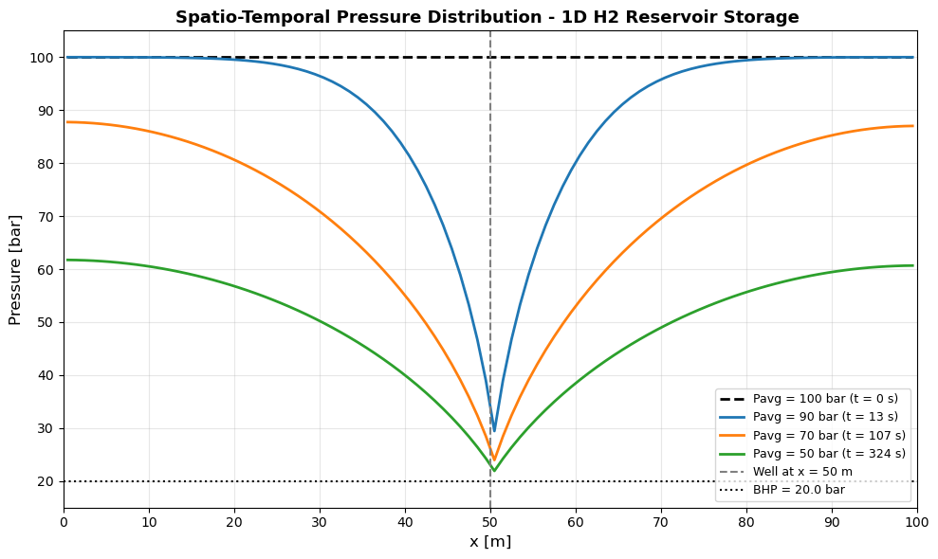
At the beginning (t = 0), pressure is uniform at 100 bar across the entire reservoir. Once production begins from the well at x = 50 m with a constant BHP of 20 bar, the pressure near the well starts to drop while the boundaries remain sealed.
The plots show pressure profiles at three observation points: P_{avg} = 90, 70, and 50 bar, captured at approximately t = 13, 107, and 324 seconds. At each step, a funnel-shaped pressure drop forms and deepens around the well, while pressure near the boundaries stays higher. This occurs because flow converges toward the well, making the pressure gradient steepest in that region.
The symmetric shape is a direct result of the well being located at the center (x = L/2), with identical sealed boundaries on both sides and homogeneous reservoir properties. At both ends (x = 0 and x = 100 m), the pressure gradient is zero, confirming the no-flow boundary condition. The well pressure never drops below BHP = 20 bar, as enforced by the Peaceman well model.
The reservoir depletes faster at early times: pressure drops from 100 to 90 bar in just 13 seconds, but later takes 217 seconds to decline from 70 to 50 bar. This is because at higher pressures, the gas is denser and the driving force is stronger, resulting in faster production. As pressure decreases, both density and flow rate decline, slowing the depletion process.

Mass Velocity Field (ρU) Simulation and Evaluation
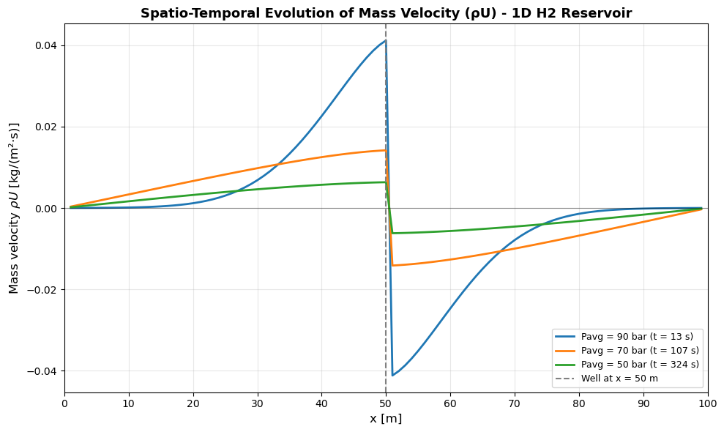
The mass velocity field ρU [kg/(m²·s)] shows how much hydrogen mass flows through each cross-sectional face per unit time. The plot is antisymmetric around the well at x = 50 m. This sign behavior follows directly from Darcy's law: U = −(k/μ)(dp/dx) with explanations:
- the left half (x < 50 m): pressure decreases toward the well, so dp/dx < 0, and U > 0. The flow moves rightward, then ρU is positive.
- The right half (x > 50 m): pressure decreases toward the left, so dp/dx > 0, and U < 0. The flow moves leftward, then ρU is negative.
The highest ρU values appear at the faces right next to the well and decrease toward the boundaries. This makes sense because the hydrogen being produced must pass through those faces, so the flux is highest there. At both boundaries (x = 0 and x = 100 m), ρU is zero, confirming that the no-flow boundary condition is satisfied.
Over time, the peak ρU drops significantly from about ±0.041 kg/(m²·s) at P_{avg} = 90 bar (t = 13 s) to ±0.007 kg/(m²·s) at P_{avg} = 50 bar (t = 324 s). This happens because: (1) as the reservoir depletes, the pressure gradient becomes smaller, so the driving force for flow weakens; and (2) gas density decreases with pressure (ρ = ρ₀p/p₀), meaning less mass is available to flow. Together, these two effects cause the production rate to decline.

Simulation of Cummulative Hydrigen Gas Production
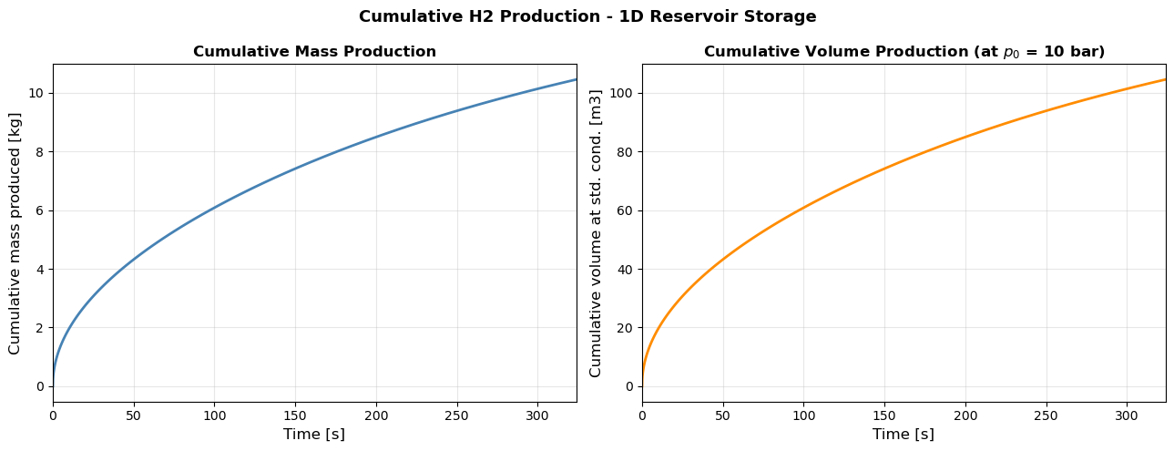

The plots show the total hydrogen produced over time, in terms of mass (in kg, left plot) and volume (m³, right plot). Both curves started with steep trend, and then flatten out over time, which means the production rate is high at the beginning and slows down as the reservoir depletes. This is as expected that at early times, the reservoir pressure is high (close to 100 bar), so the pressure difference between the reservoir and the well (BHP = 20 bar) is large, resulting a high flow rate. As pressure drops, the pressure difference weakens, and production slows down.
By the end of the simulation (t = 324 s), a total of 10.45 kg of hydrogen has been produced, equivalent to 104.5 m³ at standard conditions (p₀ = 10 bar). This volume is consistent with the mass balance, whereas the reservoir initially stored hydrogen at 100 bar, and by the end, the average pressure has dropped to 50 bar, meaning roughly half of the stored hydrogen mass has been produced.

Grid Sensitivity Analysis
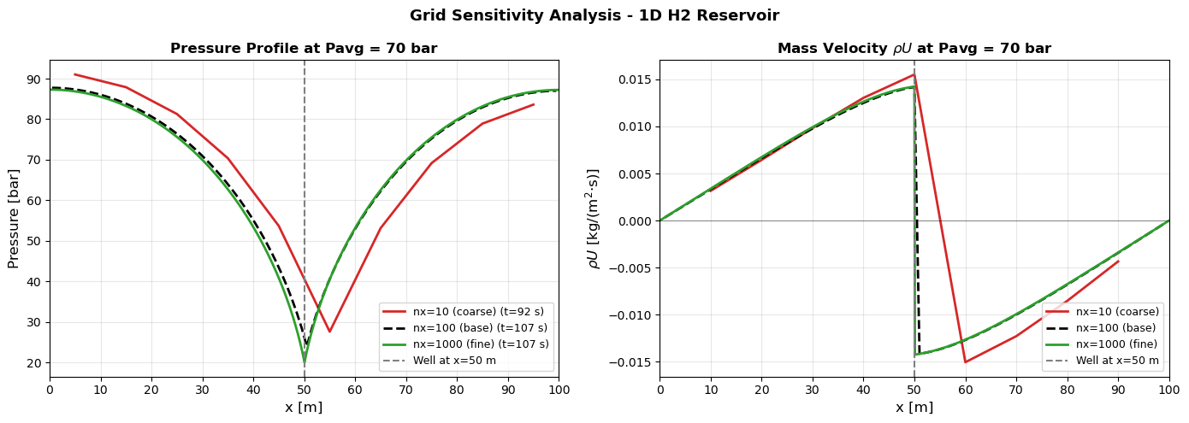
For the left graph (grid sensitivity over pressure distribution), the three grid sizes all show the same funnel shape. The coarser grid (nx=10, red curve) reaches a higher minimum pressure at the well (nearly 29 bar) compared to the finer grids (around 22 bar). This is because with only 10 large cells, the pressure gradient near the well is smeared over a wide cell, making the drawdown look less severe. The base case (nx=100, black dashed) and the finer grid (nx=1000, green) almost perfectly overlap, which means the solution has converged.
The same convergence pattern appears at the right graph (grid sensitivity over mass velocity). The base case and finer grid give nearly identical ρU profiles, with the peak inflow just before x = 50 m from both sides. The coarser grid (nx=10) shows a much sharper spike right at the well face, because the large cells force all the pressure drop into a big gradient step (overestimation of local mass flux).
A notable observation is the pressure minimum (where the production well exists) of the coarse grid is visibly shifted to the right of x = 50 m. This is a discretization artifact: as the grid is refined, the well location converges to the true geometric center at x = 50 m.
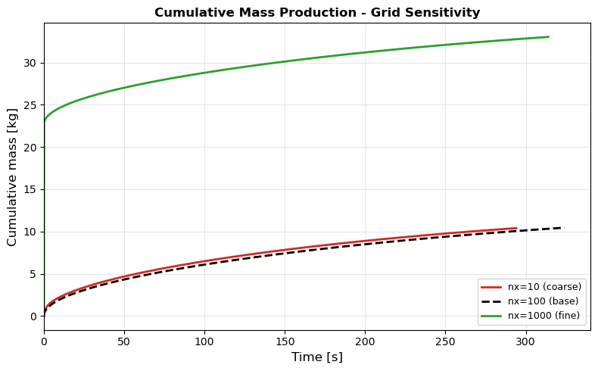
The coarse grid (nx=10) and base case (nx=100) both produce approximately 10 kg of hydrogen, showing that the cumulative production has converged and is not sensitive to grid refinement in this range. However, the fine grid (nx=1000) gives an “unrealistically” high result of about 32 kg.
Peaceman derived the formula r₀ = 0.208 Δx under the assumption that the well is located at the center of a grid cell that is significantly larger than the wellbore itself. When Δx becomes too small such that r₀ < r_{w}, the term ln(r₀ / r_{w}) becomes negative. This is not an issue of physical interpretation, but rather a direct mathematical consequence of Peaceman’s formula utilization.

Discussion
From the results, several information acquired about hydrogen flow and reservoir behavior. First, the pressure distribution shows a clear depletion pattern centered at the well. The pressure drops quickly at early time and then slows down as the reservoir becomes depleted. This shows that production is controlled by pressure difference and gas density. At high pressure, the flow is faster because both the driving force and density are higher. As pressure decreases, production declines.

Second, the mass velocity (ρU) helps us understand the flow direction and magnitude. The flow is always directed toward the well from both sides, which is expected for a production system. The highest flow occurs near the well, while no flow occurs at the boundaries due to the no-flow condition. Over time, the mass flux becomes smaller, confirming that the reservoir is losing its ability to deliver fluid as it depletes.

Third, the cumulative production results show a realistic trend: high production at the beginning followed by a gradual slowdown. The total produced mass is consistent with the pressure drop from 100 bar to 50 bar, meaning the model is physically reasonable and follows mass balance.

Finally, the grid sensitivity analysis highlights an important numerical aspect. The results from coarse and base grids are quite similar, which means the solution is already stable and converged. However, the very fine grid produces unrealistic results. This explains that not all refinements improve accuracy. In this case, the limitation comes from the Peaceman well model, which is only valid when grid cells are larger than the wellbore. If the grid is too fine, the model breaks down and overestimates production.



